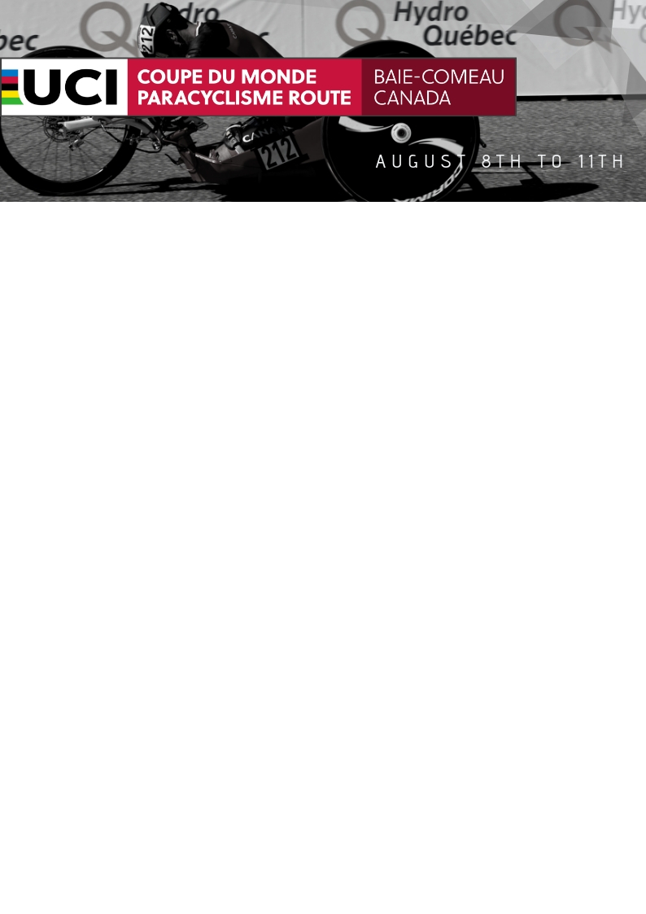

INFORMATIONS AND INTENTION FORM 2019

Dear guest,
Our team is very excited to welcome you in Baie-Comeau, a second time, for the 2019 UCI Paracycling Road World Cup! We hope you are too! Here’s the official intention form your team manager needs to fill up and to send it back to us to inform us of your needs. Then, we will be able to make a submission answering your expectations properly.
Also, you can register online by choosing one of our four packages. If you choose this way of doing, you’ll also have to contact us to confirm which package you took and your arrival and departure dates.
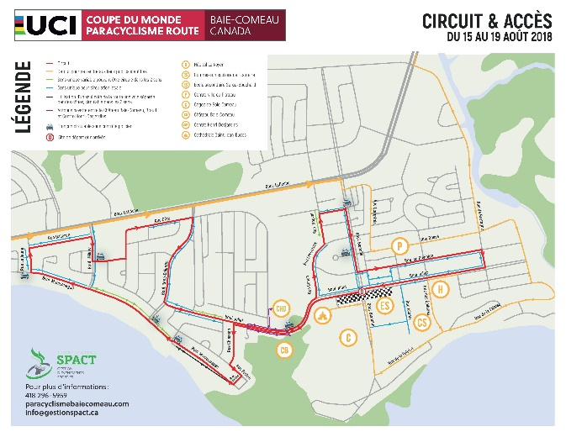
This year, we’ve made few changes based on your request and answers of our survey! Thank you again for your participation, it was very helpful for us. First, there will have, at the cafeteria, a salad and a pasta bar available all day long. Also, the sauce will be seperatly served from your plate at every meal. Second, there is a small modification made on the course. You can see it bellow.
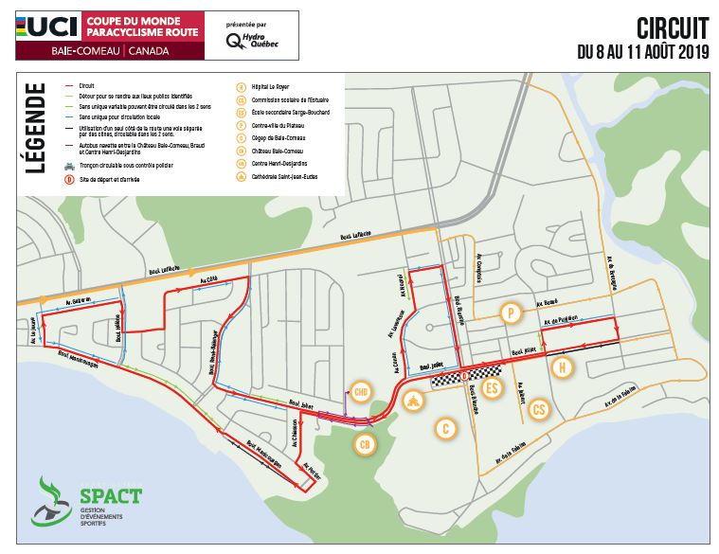
2018 2019

FORM REGISTRATION
CONTACT INFORMATION
Country :
Team manager :
Address :
Cell phone number :
Email :

TEAM INFORMATION
# of athletes :
# staff :
Arrival date in Montréal : Flight number:
Departure date from Montreal: Flight number:
Arrival date in Baie-Comeau:
Departure date from Baie-Comeau :

TRANSPORT MONTRÉAL - BAIE-COMEAU (BACK AND FORTH)
Bus
Rental car
Flight

ACCOMODATION
Room category :
1 2 3
(see package in website for the categories)
# room : Double : Single :

MEAL
# people for lunch :
# people for dinner :
# days :
Allergies:

Special request:

PAYMENT
Credit card
Bank transfer

Please fill up this form and send it back to anne-marie.villeneuve@gestionspact.ca as soon as possible to receive your submission.

If you have any other questions, contact us or visit our website www.paracyclismebaiecomeau.com !

Thank you very much!

